**Lithogeochemistry Project**

Denise Robinson

Colorado State University Global

MIS581: Capstone: Business Intelligence and Data Analytics

Dr. Jamia Mills

November 6, 2022

**Lithogeochemistry Dataset**

**Link to Github:**  <https://github.com/deniserobinson02/Lithogeochemistry>

**Project Code**

# Import packages  
import numpy as np  
import pandas as pd  
import matplotlib.pyplot as plt  
import seaborn as sns  
  
  
from sklearn.model_selection import train_test_split  
from sklearn.ensemble import RandomForestClassifier  
from sklearn.metrics import accuracy_score, confusion_matrix, classification_report  
  
# import CSV  
lith = pd.read_csv(  
 r"/Users/denise/Library/CloudStorage/OneDrive-Personal/CSU GLOBAL/MIS 581 Capstone/Raw Data/Lith_XRF_joined_Final.csv")  
print(lith.head())  
  
# create pandas dataframe and define column names  
df = pd.DataFrame(lith, columns=['Al_pct', 'Si_pct', 'S_pct', 'K_pct', 'Ca_pct', 'Ti_ppm', 'Mn_ppm', 'Fe_pct', 'Cu_ppm',  
 'Rb_ppm', 'Sr_ppm', 'Major_Unit_Interp'])  
  
# Define predictor and target variables  
X = df.drop('Major_Unit_Interp', axis=1) # predictors  
y = df['Major_Unit_Interp'] # target  
  
#view first five rows of X and y  
print(X.head())  
print(y.head())  
  
stats = df.describe(include='all').to_csv(r"/Users/denise/Library/CloudStorage/OneDrive-Personal/CSU GLOBAL/MIS 581 Capstone/Raw Data/Stats.csv")  
print(stats)  
  
  
# Split features and target into train (70%) and test sets (30%)  
X_train, X_test, y_train, y_test = train_test_split(X, y, test_size=0.3) # 70% training and 30% test  
  
# Create random forest with 500 trees  
forest = RandomForestClassifier(n_estimators = 500)  
forest.fit(X_train, y_train)  
  
# Predict the test set using the forest  
y_pred_test = forest.predict(X_test)  
  
# View random forest accuracy score  
print(accuracy_score(y_test, y_pred_test))  
  
# View confusion matrix for test data and predictions  
print(confusion_matrix(y_test, y_pred_test))  
  
# Reshape the confusion matrix for plotting  
matrix = confusion_matrix(y_test, y_pred_test)  
matrix = matrix.astype('float') / matrix.sum(axis=1)[:, np.newaxis]  
  
# Build plot for confusion matrix  
plt.figure(figsize=(14,6))  
sns.set(font_scale=1.2)  
sns.heatmap(matrix, annot=True, annot_kws={'size':8},  
 cmap=plt.cm.Reds, linewidths=0.2)  
  
# label and show the confusion matrix as heat map  
class_names = ['Basal Conglomerate'  
,'Basalt'  
,'Diabase'  
,'Diorite'  
,'Gila Conglomerate'  
,'Oracle Granite'  
,'Porphyry']  
tick_marks = np.arange(len(class_names))  
tick_marks2 = tick_marks + 0.5  
plt.xticks(tick_marks, class_names, rotation=25)  
plt.yticks(tick_marks2, class_names, rotation=0)  
plt.xlabel('Predicted label')  
plt.ylabel('True label')  
plt.title('Confusion Matrix for Random Forest Model')  
plt.show()  
  
  
# View the classification report for test data and predictions  
print(classification_report(y_test, y_pred_test))  
  
# Create feature importances for predictors  
feature_scores = pd.Series(forest.feature_importances_, index=X_train.columns).sort_values(ascending=False)  
  
# View feature importance  
print(feature_scores)  
  
  
importances = forest.feature_importances_  
std = np.std([tree.feature_importances_ for tree in forest.estimators_], axis=0)  
indices = np.argsort(importances)  
  
#plot feature importances  
plt.figure(figsize=(14,6))  
plt.bar(range(len(forest.feature_importances_)), forest.feature_importances_)  
plt.xticks(range(len(forest.feature_importances_)), X_train.columns)  
plt.xlabel("Feature")  
plt.ylabel("Feature Importance")  
plt.title("Random Forest Feature Importance")  
plt.show()

**Python Outcome Screenshots**

**Figure 1**

*PyCharm Outputs*

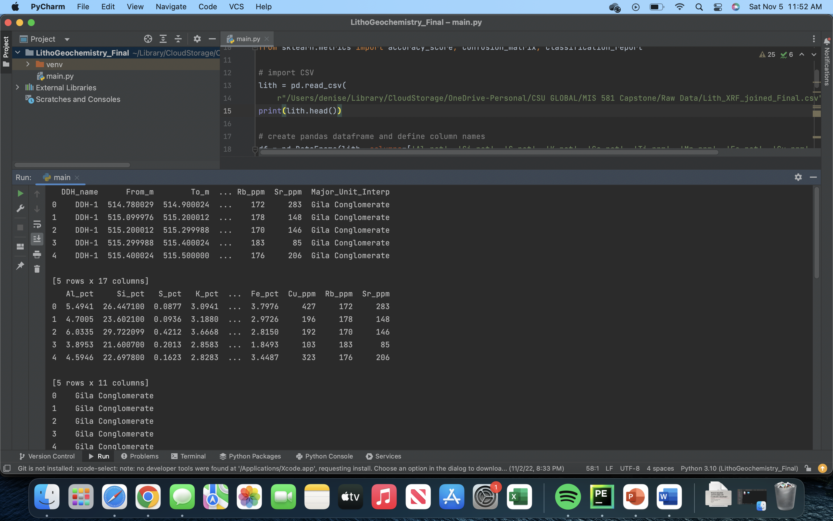

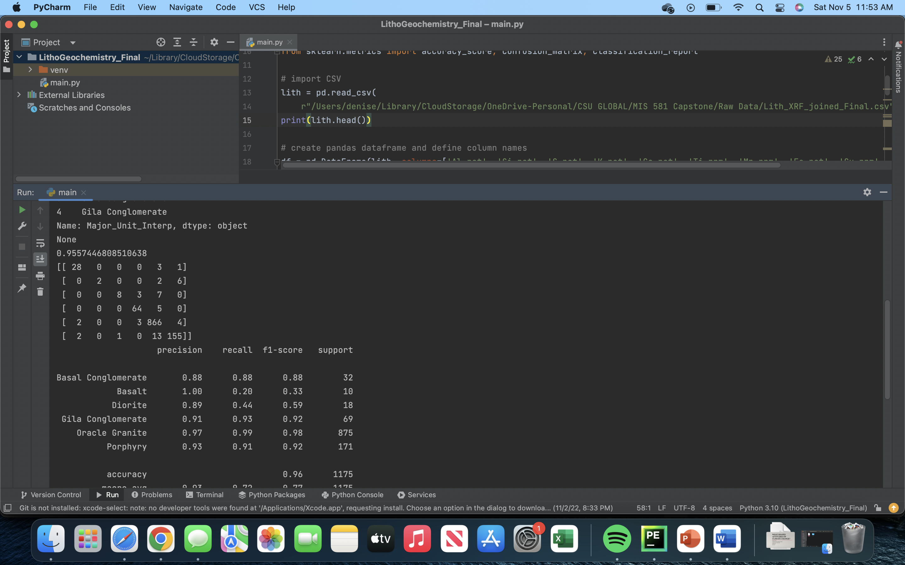

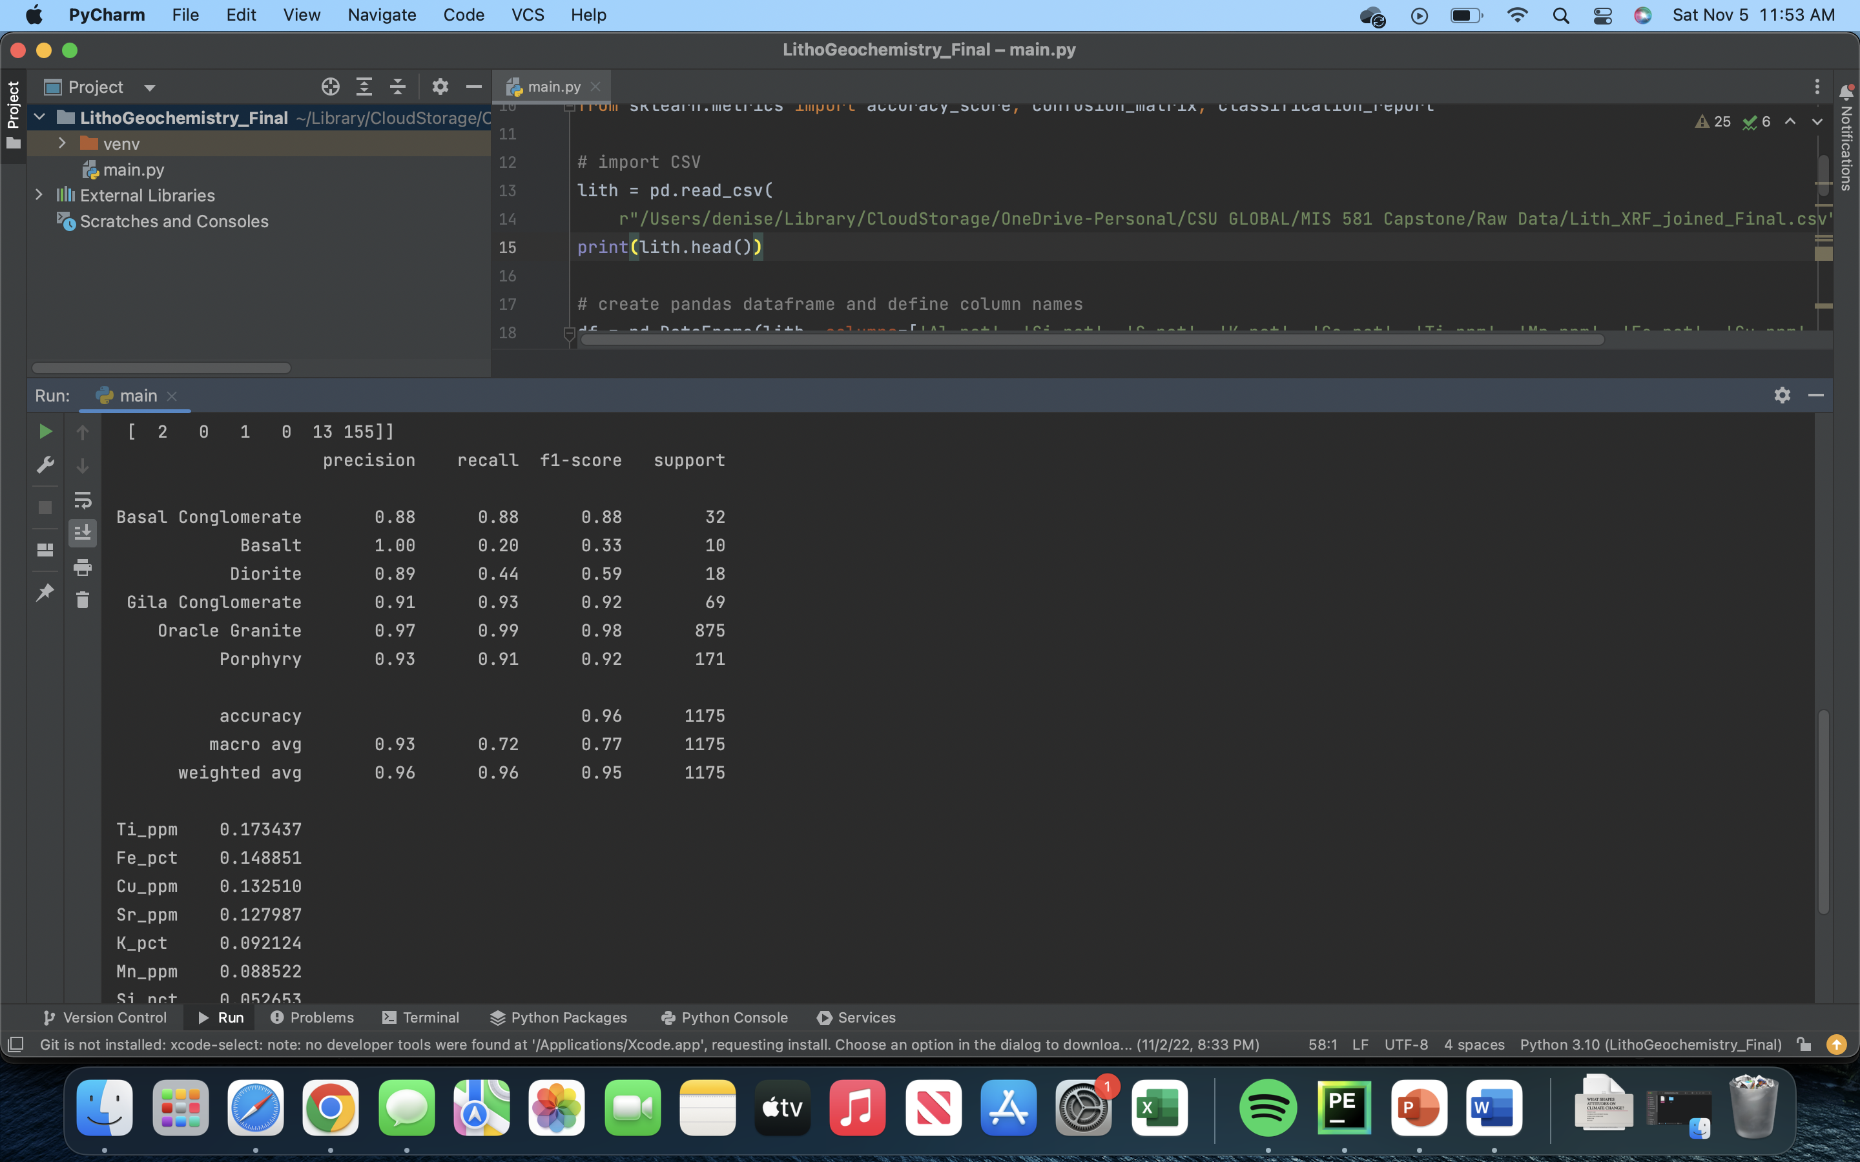

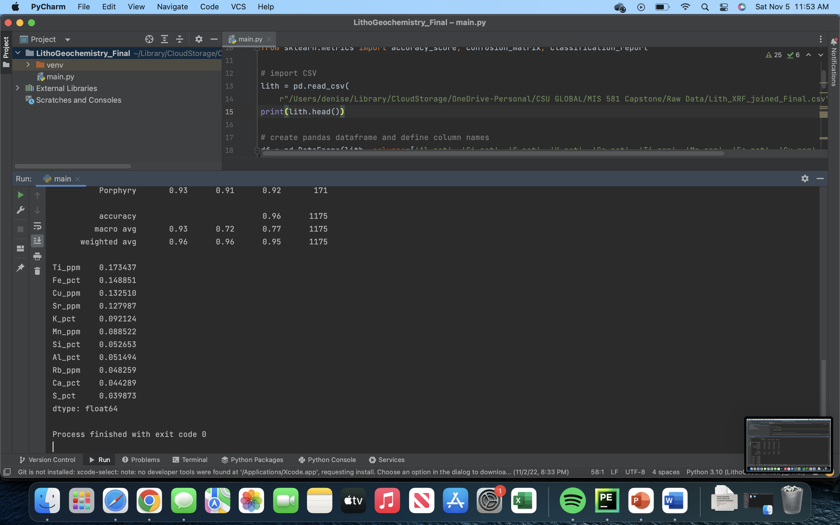

*Note*. Screenshots of PyCharm outputs

**Figure 2**

*PyCharm Output: Confusion Matrix*

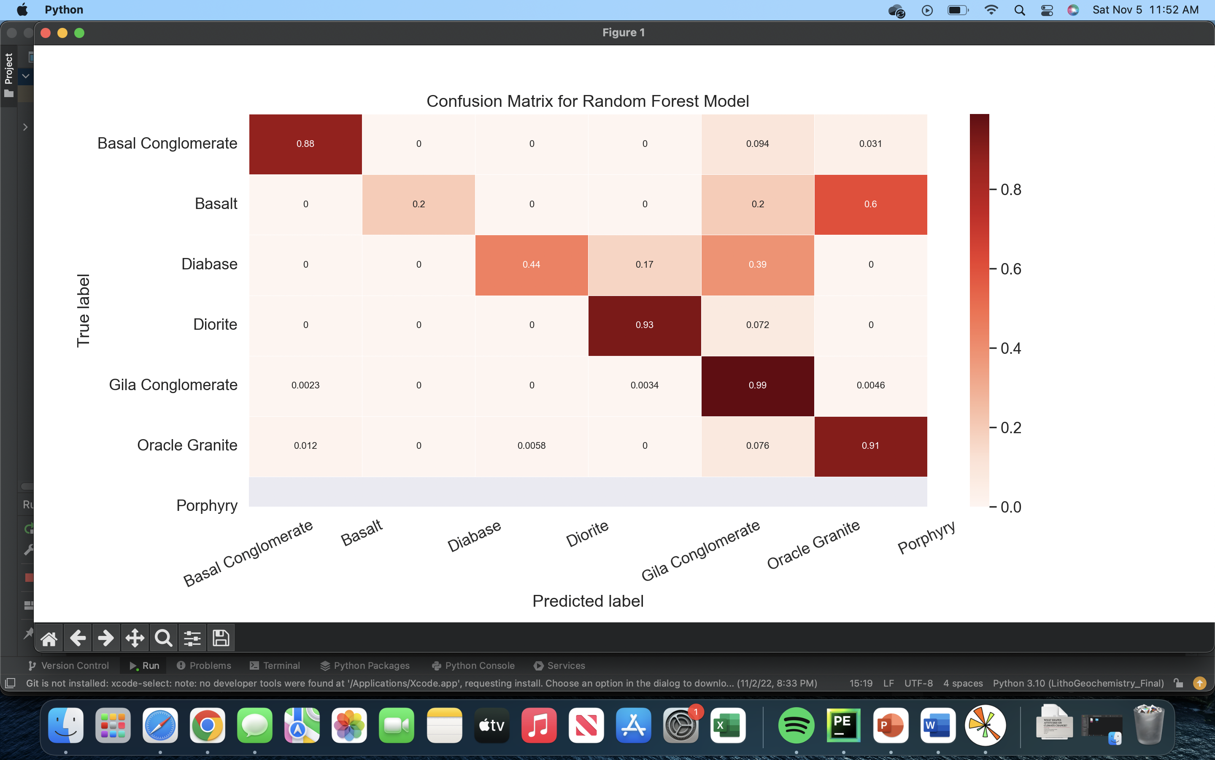

**Figure 3**

*PyCharm Output: Feature Importance*

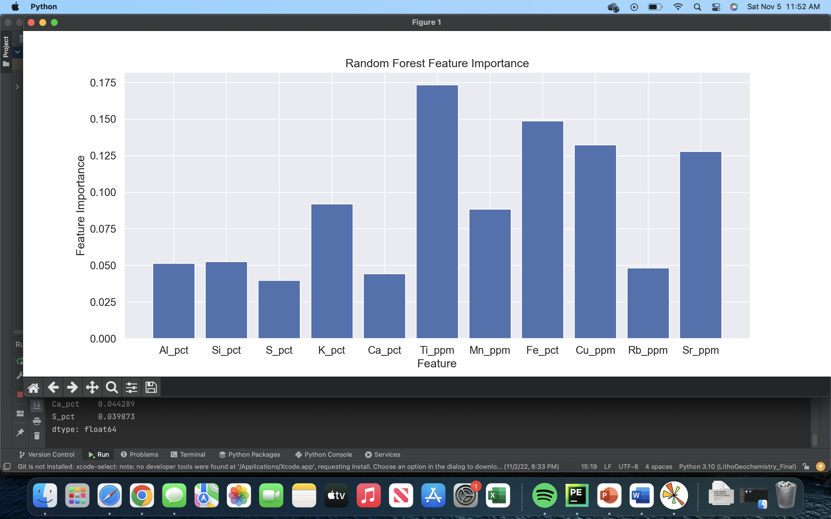

**Orange Outcome Screenshots**

**Figure 4**

*Orange Descriptive Statistics Workflow*

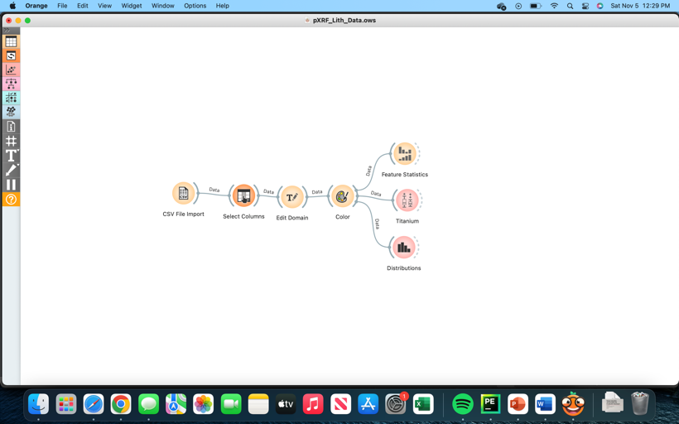

**Figure 5**

*Unit Frequency Distribution*

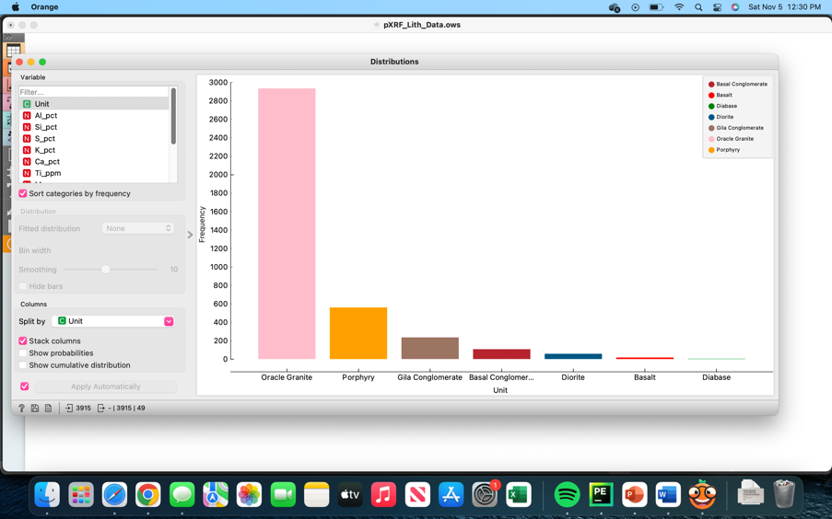

**Figure 6**

Descriptive Statistics

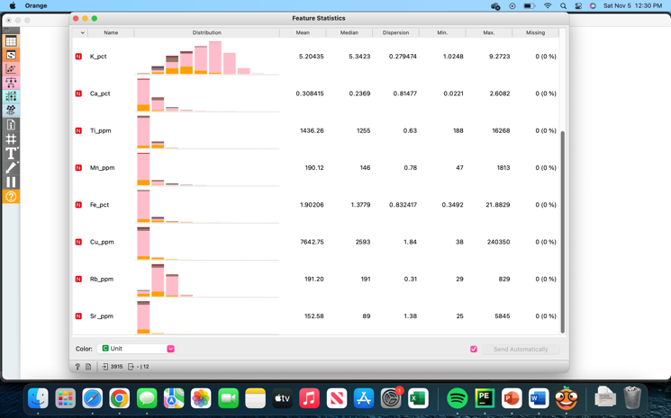

**Figure 7**

*Titanium Distribution Across Lithology Units*

